The Waltham Group
Newsletter JULY/AUGUST/SEPTEMBER 2025 issue

Welcome + share + grow

Dear Friends
Welcome to our quarterly newsletter. As always looking forward can always seem to be a bit of a mystery. We never know what may be just around the corner. I have often thought that if anyone had told me 5 years ago (when I was living in Leicestershire) that, not only would I be living in Waltham, but also looking after 6 churches in as many villages, I would have said that they were dreaming. However, I am here and truly enjoying the experience.
I wonder if you have ever had a moment to stop and think about your life and where you are right now and whether you are amazed at what has happened in the past 5 years. But what about the future? We cannot, however hard we try, predict our future. So much can happen in 5 years. Children are born, marriages are made or broken, new jobs, new locations, just to mention a few.
As Christians we are told not to worry about tomorrow. In the Bible Matthew chapter 6 verse 34 simply says ‘So don’t worry about tomorrow for tomorrow will bring its own worries. Today’s trouble is enough for today’. Christians believe that our worries whether present or future are placed firmly in the hands of the God who care for us. Of course, I believe this to be true.
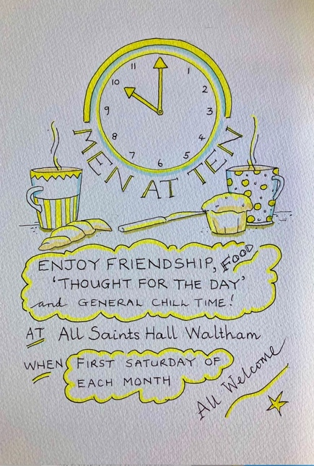
At All Saints Church in Waltham every Thursday morning at 09.30am, we pray for everyone and again at our Gathered Together service on Sunday mornings at 10am we sing together and pray for everyone. You will find further services in our other group churches over the next 3 months and we hope to see you there. You are welcome to join us and of course enjoy some cake and refreshment after the service.
iEvery First Saturday of the Month
But here’s our saving grace: God does not leave us alone and bereft. We are not direction-less in the wilderness. In other words, God’s commandment to us is not that we should wear ourselves out worrying about things we have absolutely no control over. What is important is that we care and look after each other as best we can.
Reverend Pauline Cummins

Telephone: 01472 281424
Find us on https://walthamgroupchurches.co.uk
Facebook https://www.facebook.com/walthamgroupchurches
Achurchnearyou https://www.achurchnearyou.com/church/15023/

Waltham Group Rota – Waltham, New Waltham (NW), Brigsley (B), Ashby cum Fenby (ACF), Barnoldby le Beck (BLB) 2025 Service times 10.00am East Ravendale (ER) 09:00am

July | 6th Trinity 3 | 13th Trinity 4 | 20th Trinity 5 | 27th Trinity 6
All Saints  Waltham 10am | Service of the Word 10am | Joint Eucharist  10am | Eucharist Service/Baptism | Eucharist Service
St Matthew’s  NW 10am | Eucharist with Baptism Service  10am | Greek Orthodox Service | Service of the Word 10am | Service of the Word
August | 3rd Trinity 7 | 10th Trinity 8 | 17th Trinity 9 | 24th Trinity 10 | 31st Trinity 11
All Saints Church  Waltham 10am | Service of the Word | Joint Eucharist | Eucharist with Baptism Service | Eucharist Service | Joint Service  Wholeness and Healing
St Matthew’s  NW 10am | Joint/Methodist Eucharist Service | Greek Orthodox Service | Service of the Word | Service of the Word
St Martin’s ER 09am |  |  | BCP Eucharist Service
St Peters ACF 4pm |  |  | Eucharist with Baptism
St Helens Brigsley 10am |  |  | Service of the Word
September | 7th Trinity 12 | 14th Trinity 13 | 21st Trinity 14 | 28th Trinity 15
All Saints  Waltham 10am | Service of the Word | Eucharist Service with Baptism | No Service as Joint Service at St Matthews NW | Eucharist Service
St Matthew’s  NW 10am | Eucharist Service with Methodist | Greek Orthodox Service | Joint Eucharist Service 40th Anniversary | Service of the Word Harvest Festival
St Helen’s  Brigsley 6pm |  |  |  | Harvest Festival 6pm
Additional Services/Events
Every Thursday Morning – Morning Prayer at 09.30am All Saints Church, Waltham

September- Saturday 13th All Day - RIDE’N’STRIDE – All churches will be open

All Saints Church, Waltham. Monthly Every 1st Saturday Men at Ten. 10am
Every 4th Saturday Coffee, Tea, Cake and Stalls 9.30 – 12noon
St Martins Church, East Ravendale. Every Thursday Coffee Morning 09.30-11am
St Matthews Church, New Waltham Every Saturday Coffee Morning 10am – 12noon
Every Tuesday Cake, Quiet and Compline – 7pm-8.30pm
St Helens Church Brigsley Every 1st Saturday Coffee Morning 10am – 12noon
St Helens Church Barnoldby le Beck Every 3rd Saturday Coffee Morning 10:30am – 12noon

